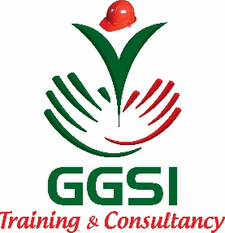
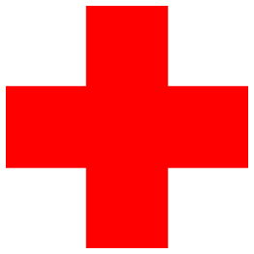
- Bleeding and shock
GREEN GLOBAL SAFETY INSTITUTE
FIRST AID TRAINING

- Burns
- Poisoning
Who is it for?
We offer First Aid Course for people who would like to learn first aid to help their family or friends rather than as a requirement of their job. No previous experience is needed and these courses are run in a way which makes learning first aid and easy to remember. Great for building confidence to help outside of the workplace.
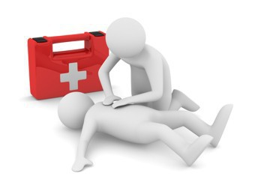
- Heart attacks and chest pains
- Strokes
- Seizures
- Fractures and dislocations
- Soft tissues injuries
- Allergic reactions (anaphylaxis)
- Asthma
- Diabetes
Bleeding and shock
Training Objectives
- Chain of Survival
- What is First Aid?
- Scene Survey
- Initial Assessment Sequence
- Victim Assessment Sequence
- CPR-Cardiopulmonary resuscitation

Burns
Poisoning
Heart attacks and chest pains
Strokes
Seizures
Fractures and dislocations
Bleeding and shock
Burns , Poisoning
Heart attacks and chest pains Strokes , Asthma ,Diabetes
Soft tissues injuries
Seizures, Fractures and dislocations, Soft tissues injuries, Allergic reactions (anaphylaxis)
Scene and hazard management ,Patient positioning and assessment, CPR (Adult ) Defibrillator ,(AED) use Choking (Adult, Child, Infant) ,General care, Medical Emergency Plan

Allergic reactions (anaphylaxis)
Asthma
Diabetes Bleeding and shock
Burns
Poisoning
Heart attacks and chest pains
Strokes
Seizures
Fractures and dislocations
Soft tissues injuries
Allergic reactions (anaphylaxis)
Asthma

