GREEN GLOBAL SAFETY INSTITUTE

Fire & Safety….Audit
- Has the fire safety inspection been carried out in your block.
- Safety commmitte details
- Safety inspections
- Personal protective equipment
- Work permit systems
- Are there proper work permit systems to control work on new buildings renovation repairs and decoration of premises such that no fire hazards are introduced
- If any permit work systems are in place are they operated correctly at all times
- Fire prevention protection and fighting system
- Store Room storage details displayed in front of the room
- Safety board
- Is the risk assessment properly reviewed particularly if the premises or its use significantly changed
- Do staff understand the need to report any potential fire hazards
- Are all heating appliances securely fixed in position suitably guarded and with an adequate clear space free of storage of any kind
- Are all emergency exits doors easily operable from the inside free from obstruction
- Are emergency exit doors in good condition
- list of fire extinguisher firefighting equipments alarm system available in your block
What is Fire Safety Awareness
Fire Safety Awareness is for people at any level, in any sector worldwide, who need a grounding in the essentials of fire safety What Peace of mind from training that’s designed and quality-controlled by IOSH the Chartered body for safety and health professionals - Minimal disruption to working days and shifts – the programme is delivered in just half a day, including the assessment - Efficient and effective learning –

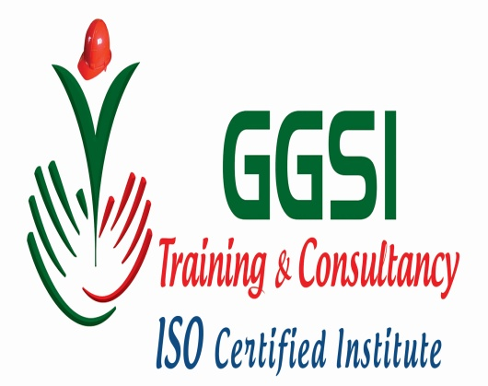

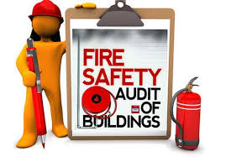
fire safety basics are covered in a single, self-contained session
  - CONTACT US
43/7B , SENTHIL NAGAR, CHINNA KODUNGALYUR
CHENNAI-51
PHONE NUMBER: +91 8610301339
EMAIL.ID :INFO@GREENGLOBALSAFETYSYSTEMS.COM

